19 Apr 10 Copies: QMSI / Patient

PHYSICAL ABILITY PROFORMA (DMICP)

No:Service Number Rank:Rank/Title Name:Surname Unit:Contact Address List Dept:
JMES Grade: Injury / Condition:
Date of issue: System Date . Review due date: Completed by: User Title User Name

Where appropriate, indicate areas affected below:

R L L R
Front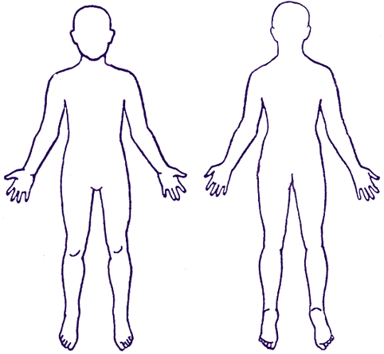Back

Cardiovascular: 1. Treadmill:
2. Cycling machine:
3. Rowing Machine:
4. Stepper:

Running: . Distance: km. Time: mins

TABs: Weight: kg. Distance km. Time: mins

Circuit Trg: 1. Shoulder:
2. Elbow:
3. Spine:
4. Hip flexors:
5. Knee:
6. Ankle:

Mil Swim Test: Swimming:

PFT: attempt PFT. The requirements according to sex and age are below.
pressups, sit ups, 2.4km run time
press ups, sit ups, 2.4km run time
CFT:

Battle PT: join in with Battle PT. Remarks:
Sports: Contact sports / Competitive level:

Comments:

Declaration: I give my consent for information on this form to be used by the QMSI to enable him to arrange an appropriate PT programme for me. This form will be retained by the QMSI unless I am upgraded MFD, or until review and issue of an updated form. A copy will be retained in my medical record. I have been offered a copy of this form. I happy for this form to be shown to, or discussed with, my chain of command.

Signed:________________________ Date: ______________

